 | Harmony Highlights |  |  | 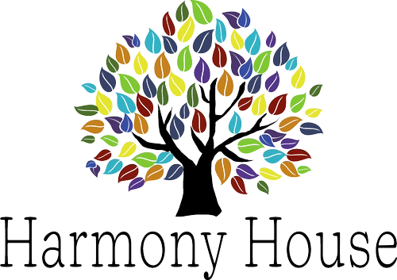
 | ISSUE NO #2 | July – September 2026 | |  |  | Birthday Celebrations
 |  | 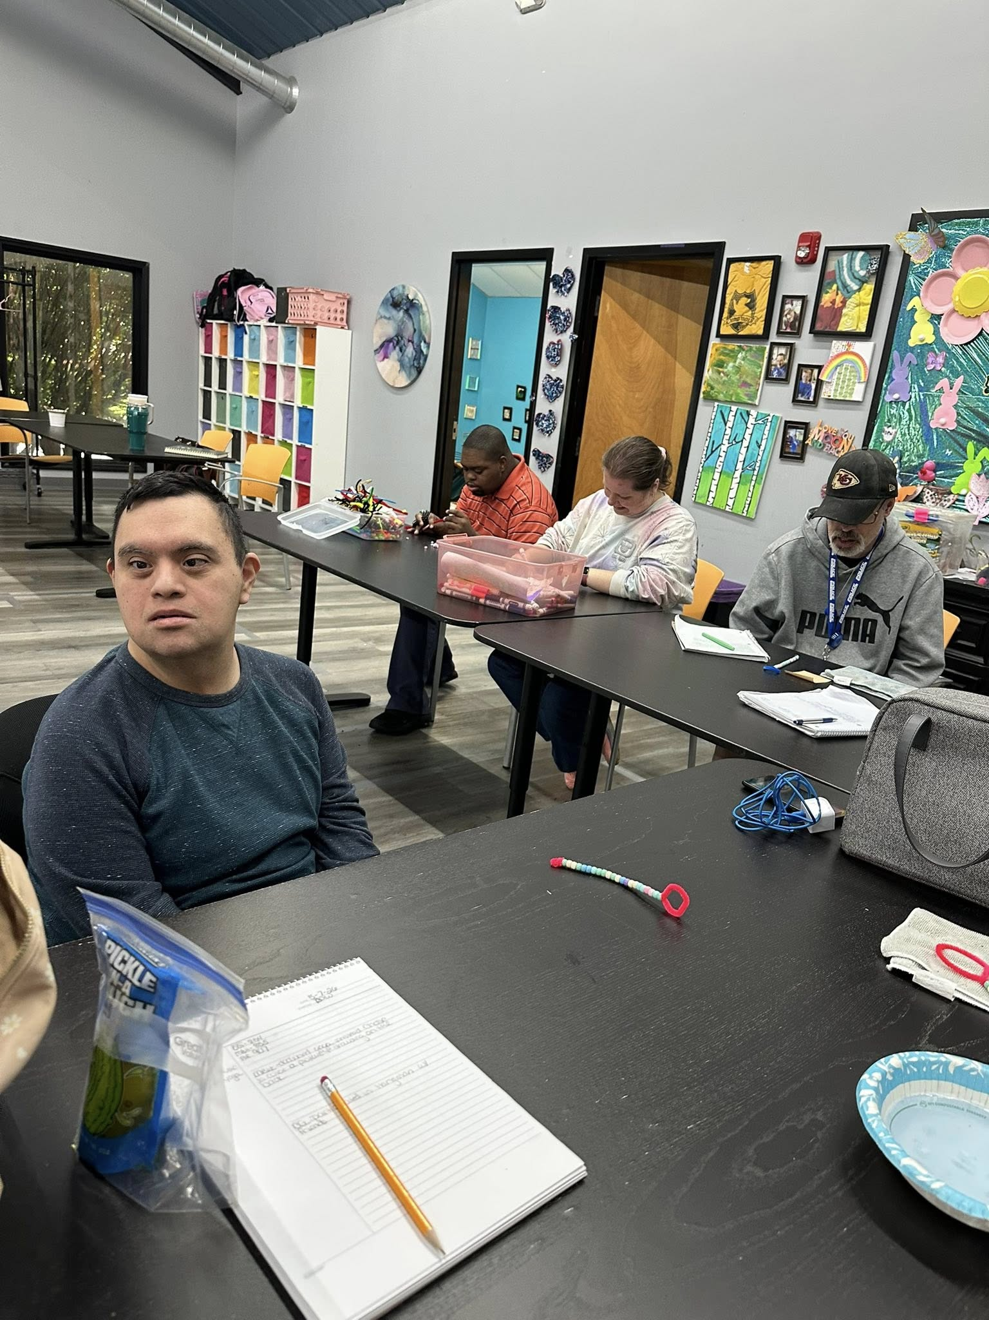 |  | NW 7/3  KB 7/10  NW 7/11  ML 7/13  MJ 7/16  BK 7/17  MH 7/17  TK 7/19  MR 7/20  JJ 7/24  CC 8/8  MF 8/10  TA 8/17  TH 8/17  ES 8/28 |  | MR 8/26  BA 9/9  DW 9/12  JC 9/23  MM 9/23  DS 9/25  AR 9.26 | Carmen 7/9  Kaleigh 7/12  Kelli 7/12  Robyn 7/15  Rachel M 7/18  Logan 7/21  Marquita 8/1  Irene 8/14  Amy 8/15  Jessica 8/17  Michelle 8/26  Colleen 9/1
Star of the Quarter
"Logan is recognized as Star of the Quarter for exceptional advocacy, ensuring an individual's pain management needs were addressed promptly and effectively, demonstrating compassion, persistence, and a strong commitment to quality care."
 | A Few Words from us:
 | Summer is in full swing, and we've already shared many memorable experiences together through community outings, special events, and everyday moments that make a difference. As we continue through the season, we're grateful for the energy, dedication, and teamwork that help make Harmony House such a positive place to live and work.  Thank you for all you do each day to uplift those around you. We hope you enjoy this edition of Harmony Highlights as we celebrate accomplishments, share updates, and recognize the people who make Harmony House such a special community. |  | This quarter, we're focusing on the value of Encouragement. Encouragement is more than offering praise—it's helping others recognize their strengths, celebrating progress, and supporting one another through challenges. A kind word, a listening ear, or recognition of a job well done can have a lasting impact on both the individuals we support and our fellow team members. | Star of the Quarter  DS is recognized as Star of the Quarter for serving as a trusted advocate for a peer by communicating concerns to staff, helping ensure the peer received support and that their concerns were addressed when they were hesitant to speak up for themselves.

ISSUE NO #2 | July – september 2026 |
Value of the Quarter: Encouragement
Encouragement means helping others feel supported, confident, and valued. Through kind words, recognition, and positive actions, we can inspire growth and help others succeed. At Harmony House, encouragement strengthens relationships, builds confidence, and creates a positive environment where everyone can thrive.
Value Lesson: Encouragement
Encouragement is more than offering praise, it is intentionally helping others see their potential and supporting them along the way. Whether someone is learning a new skill, facing a challenge, or working toward a goal, encouragement can provide the confidence needed to keep moving forward.
Practicing encouragement can be as simple as recognizing effort, celebrating small victories, listening with empathy, or offering reassurance during difficult moments. These actions help create an atmosphere where people feel respected, supported, and capable. When encouragement becomes part of our daily interactions, we foster growth, resilience, and a stronger sense of community. Small words of support can have a lasting impact and help others achieve more than they thought possible.
“Too often we underestimate the power of a touch, a smile, a kind word, a listening ear… all of which have the potential to turn a life around.”
— Leo Buscaglia
“Small acts, when multiplied by many people, can transform a community.” — Howard Zinn

Community Events
July  7-11 Oak Grove Pool Party  7-16 Movie Music Bingo  7-23 Christmas in July Bingo  7-25 Water Carnival | August  8-6 50/60’s Music Bingo  8-9 Oak Grove Pool Party  8-13 70/80’s Music Bingo  8-18 90/00’s Music Bingo  8-27 10/20’s Music Bingo | September  9-17 Country Music Bingo  9-24 Prom
Please RSVP for Community Events through our website www.harmonyhousecarehomes.com under our events tab.
ISSUE NO #2 | July – September 2026 |
Heads Up & Reminders
• Continue using SCOMM for all non-emergency communication to help keep communication clear and organized.
• Summer temperatures are still high—remember to stay hydrated, wear sunscreen, and take precautions during outdoor activities.
• Be sure to check for ticks after outings and report any concerns promptly.
• Review upcoming community event calendars and activity schedules to stay informed and prepared.
• Please ensure all required trainings and documentation are completed by their assigned deadlines.
• Weather can be unpredictable—be prepared with appropriate clothing and footwear for changing conditions.
• Take care of yourself, too. Remember to take breaks, stay hydrated, and prioritize your well-being during busy shifts.
• Fall events are just around the corner. Watch for announcements regarding seasonal activities, community festivals, and holiday planning.
• Continue practicing our PEACE values in every interaction and take time to recognize the positive contributions of your coworkers and individuals we support.

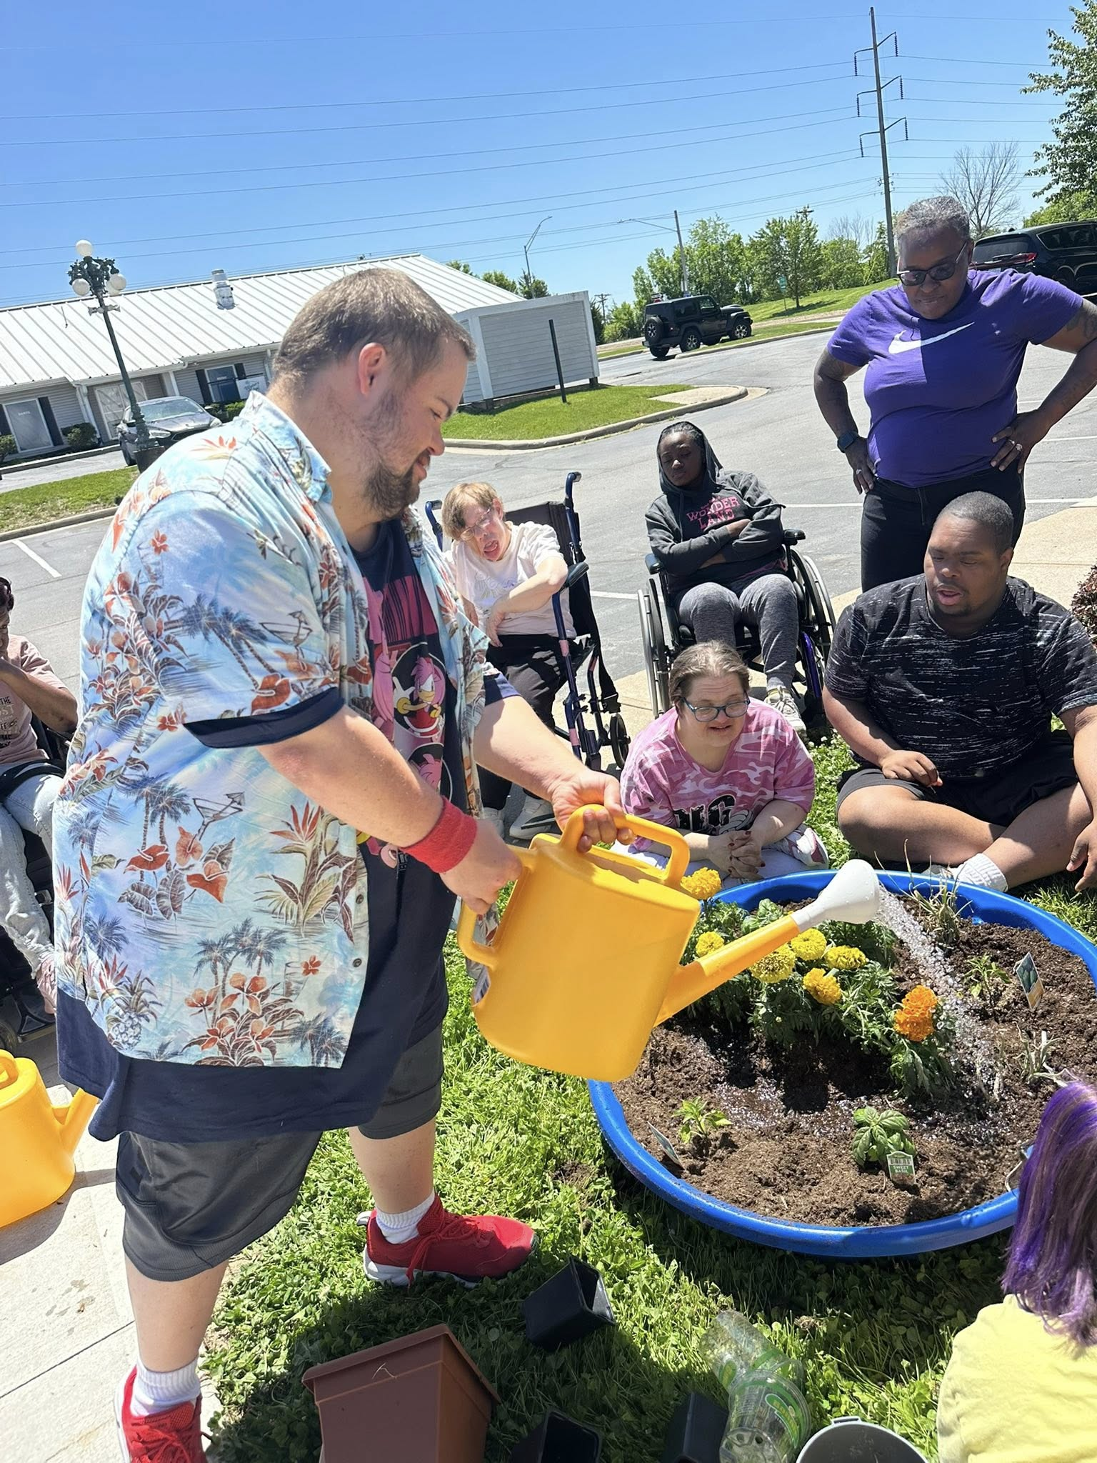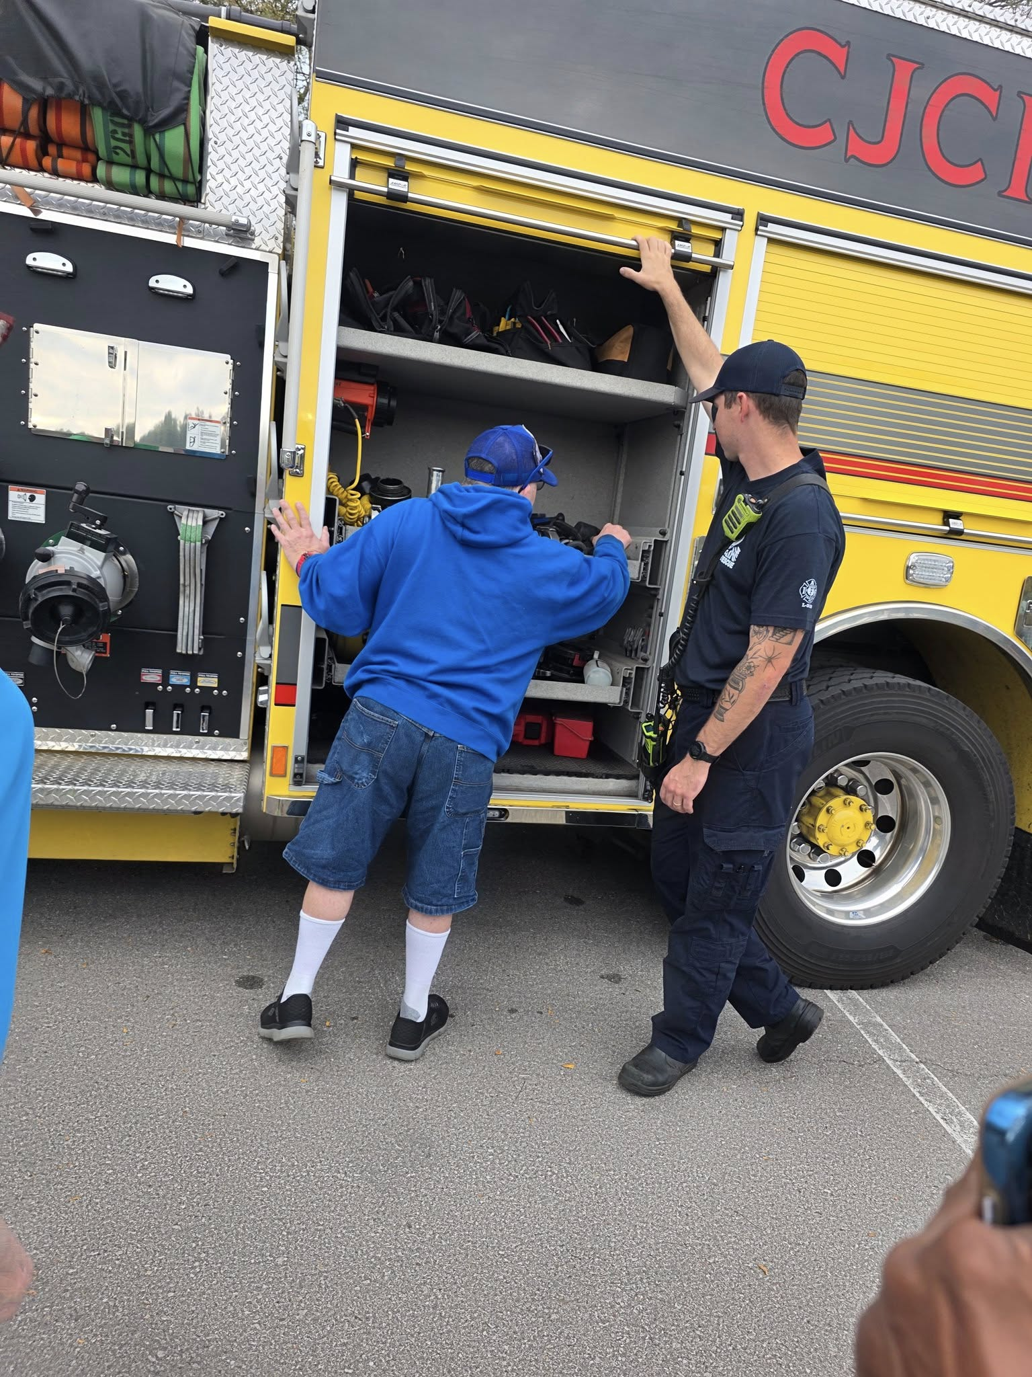
Quick Tip:
Patience is one of the simplest ways to show respect and compassion.

What’s New at Harmony House
We've had an exciting and active summer so far! Community outings, special events, and seasonal activities have kept everyone engaged and connected. From enjoying local attractions to participating in summer celebrations, it's been wonderful to see so many opportunities for fun, growth, and community involvement.
We're also looking forward to celebrating DSP Week and recognizing the incredible dedication of our Direct Support Professionals. In addition, staff will continue participating in training and development opportunities to help us provide the highest quality support possible.
Be sure to stay tuned for upcoming events, community activities, and recognition opportunities throughout the rest of the summer. Thank you for all you do to make Harmony House a positive, welcoming, and supportive place for everyone.

